Guidelines for ODF’06 Nara

Technical Digest Manuscript Preparation, 14 Point Type

Hanako Seimitsu (1), Ichiro Kogaku (2), Taro Sekkei (3)

1 : Opcics Research Center, Nara Optics University, Japan

2 : Institute of Consumer Optics, Optics Corporation, Japan, 3 : R&D division, ODF Inc., 9 Point Type
Abstract: Abstract should be the same as the 35-word abstract which will be submitted with this manuscript. Scientific or engineering symbols or acronyms should not be included inside the abstract. Font size should be 9 pt.
© 2006 OSJ

1. Introduction
A template is a set of styles and page layout settings that determine the appearance of a document. This template matches the printer settings that will be used to the proceeding. In order to provide a consistent appearance of the manuscripts, it is important for the authors to use this template.

2. Title section
Paper size should be 21 cm x 29.7 cm A4 size or US Letter, 8.5 in. x 11 in. Margins should be set for a 2.6 cm top, a 2.2cm bottom, and a 2.2cm left and right. The page length should be 2 pages. Over length manuscripts are not accepted. The font should be Times New Roman.

2.1 Title, Authors’ names, and Author affiliation
Center the title. The First letters of every word are capitalized. The title should be in 14 pt., bold font. Center author names using 9 pt. Authors’ names should appear as used for conventional publication, with first and middle names or initials followed by surname. Center author affiliations using 9 pt. Affiliations should follow the format: division, organization, country.

2.2 Abstract
The abstract section should be started with the word “Abstract” in bold, followed by a colon. Font size should be 9 pt. The abstract should be an explicit summary of the paper. The abstract should be the same as the 35-word abstract which will be submitted with this manuscript.

2.3. Copyright
The authors are required to add the following line immediately after the abstract:
© 2006 OSJ

3. Main text
The main text should be set in two-column format with a minimum gutter between the columns of 8mm. Font size should be 10 pt. The first line of the first paragraph of a section or subsection should be left aligned.

4. Figures, Photos, Tables, and Equations
Figures, photos, tables, and equations should be in black-and-white. Captions should be placed under the figures and the photos, and above the tables. Font size for the caption should be 10 pt.
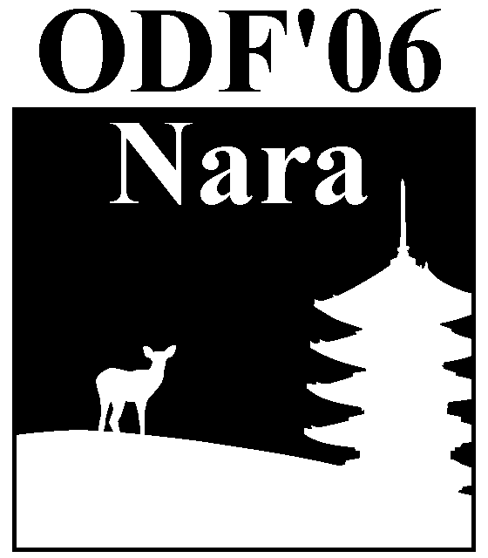
Fig.1. Sample figure from ODF’06 Logo

Table 1. Sample table
λ(nm) | A. | B. | C.
400 | 100 | 0.01 | 645
500 | 200 | 0.02 | 710
700 | 300 | 0.04 | 1192
800 | 400 | 0.16 | 1860

Equations should be centered. The number of the equation can be given if necessary.
$φ=\sum_{i=1}^{m}{φ_{i^{′}}}+\sum_{j=1}^{l}{φ_{i^{″}}}$ (1)

5. Conclusions

Describe the conclusions of your paper consicely.

6. References
References should be set at the end of the manuscript. The reference numbers should be consistent with the order in which they are cited in the body of the paper.
1) P. Nara and Q. Tokyo: Opt. Rev. 6 (1999) 321
2) I. Kogaku and H. Seimitsu: Jpn. J. Appl. Phys. 75 (2004) 1234
3) E. Proceedings: Proc. ODF, 2002, p456

7. Copyright Transfer Agreement

The copyright of the article published in the ODF’06 Technical Digest is to be transferred to the Optical Society of Japan (OSJ). The authors are required to agree to the copyright transfer in the online submission procedure at the same time as the 35-word abstract and the 2-page manuscripts are submitted.

8. Deadline
Deadline for online submission of the 35-word abstract and the 2-page manuscript is May 31, 2006.

